A USBR WaterSMART Cooperative Watershed Management Grant

“To mobilize a diverse group of North Fork Payette River Watershed stakeholders to identify watershed challenges, develop Watershed Restoration Plan and identify funding sources for plan implementation.”

**North Fork Payette River Watershed Coalition**

**Donnelly Community Kickoff**

**Date/Time**: January 11, 2024 | 4-6PM **Location**: Donnelly Community Center

* Grab some chili and explore the NFPR Watershed maps, introduce yourself to others
* Brief introduction to the NFPR Watershed Coalition
  + County Commissioner and VSWCD Supervisor Greeting
  + Introduction to our grant and local watershed challenges

*Lenard Long - Friends of Lake Cascade, Associate Supervisor*

*Valley Soil & Water Conservation District*

* Round Table Sharing
  + What are your areas of concern?
  + What are your areas of interest?
  + Share interests and concerns with other groups
* Interactive Watershed Map Demonstration
  + Learn how to input your concerns and ideas to the map

*Kara Utter - Dynamic Visions GIS*

* What’s Next?
  + Feb 15 NFPRWC Workshop
  + 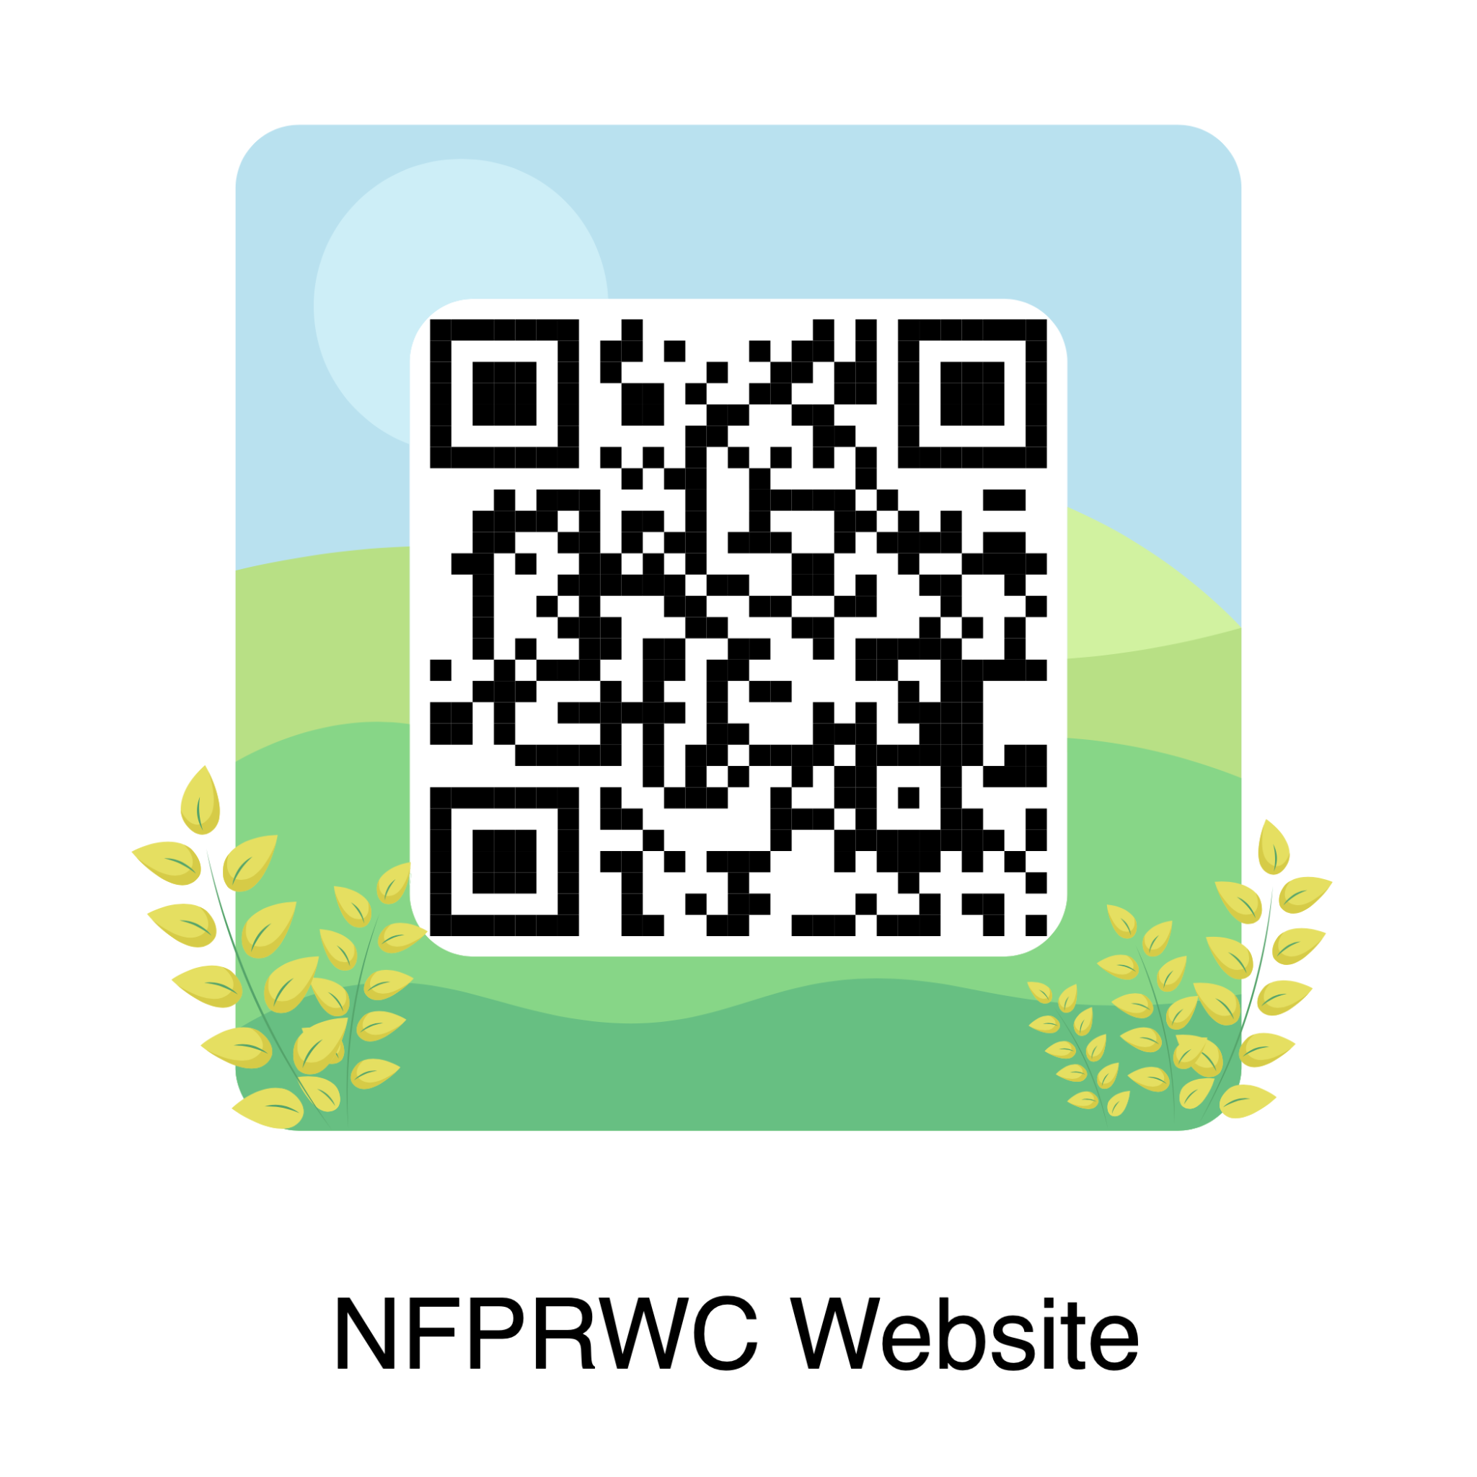Sign up to volunteer