A USBR WaterSMART Cooperative Watershed Management Grant

“To mobilize a diverse group of North Fork Payette River Watershed stakeholders to identify watershed challenges, develop Watershed Restoration Plan and identify funding sources for plan implementation.”

**North Fork Payette River Watershed Coalition**

**Cascade Community Kickoff**

**Date/Time**: January 17, 2024 | 4-6PM **Location**: Cascade American Legion Hall

* Grab some chili, cookies and explore the NFPR Watershed maps, introduce yourself to others, socialize and network as you wish.
* Brief introduction to the NFPR Watershed Coalition
  + County Commissioner and VSWCD Supervisor Greeting
  + Self Introductions around the room
  + Introduction to our grant and local watershed challenges

*Lenard Long - Friends of Lake Cascade, Associate Supervisor*

*Valley Soil & Water Conservation District*

* Interactive Watershed Map Demonstration (Kara Utter, Dynamic Visions GIS)amic Visions GI
  + Learn how to input your concerns and ideas to the map
* 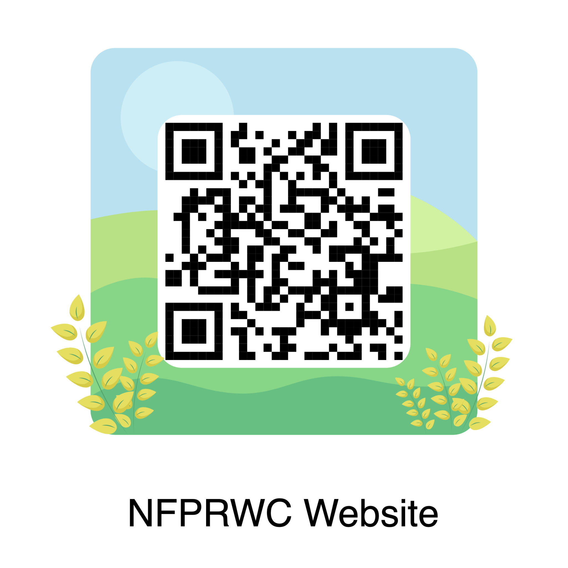Round Table Sharing
  + What are your areas of concern?
  + What are your areas of interest?
  + Share interests and concerns with other groups
* What’s Next?
  + Feb 15 NFPRWC Workshop
  + Sign up to volunteer

**Watershed Inventory Map:** <https://arcg.is/1zjTCr>

**Contact:**  Durena Farr, District and NFPR Watershed Coalition Program Manager, Durena.Farr@id.nacdnet.net or NFPRWatershedCoalition@outlook.org