A USBR WaterSMART Cooperative Watershed Management Grant

“To mobilize a diverse group of North Fork Payette River Watershed stakeholders to identify watershed challenges, develop Watershed Restoration Plan and identify funding sources for plan implementation.”

**North Fork Payette River Watershed Coalition**

**Watershed Workshop No. 1**

* Grab cookies and a drink! (5 min)

Explore the NFPR Watershed maps, introduce yourself & mix with others

* Community Welcome (10 min)
* History of the Watershed (20-30 min)

*Ken Roberts, Lance Holloway, Art Troutner*

* State of the Watershed (20-30 min)

*Dani Terhaar, Idaho Department of Environmental Quality*

* A word about why we're here - potential funding (5 min) *Melissa Jayo, USBR*
* Watershed Topic Sheet Discussion (David Nichols) (30-35 min)
  + Your Areas of Concern submissions in action (?)
  + Small group discussions: What topics did you rate the highest? Why?
  + Large Group Discussion: What themes do we see?
* What’s Next? (5 min)
  + Interactive Map Review - Reminder to keep adding data (5 min)
  + Help get the word out about the Coalition to expand participation
  + Your feedback matters! Take a survey at the front table.
  + 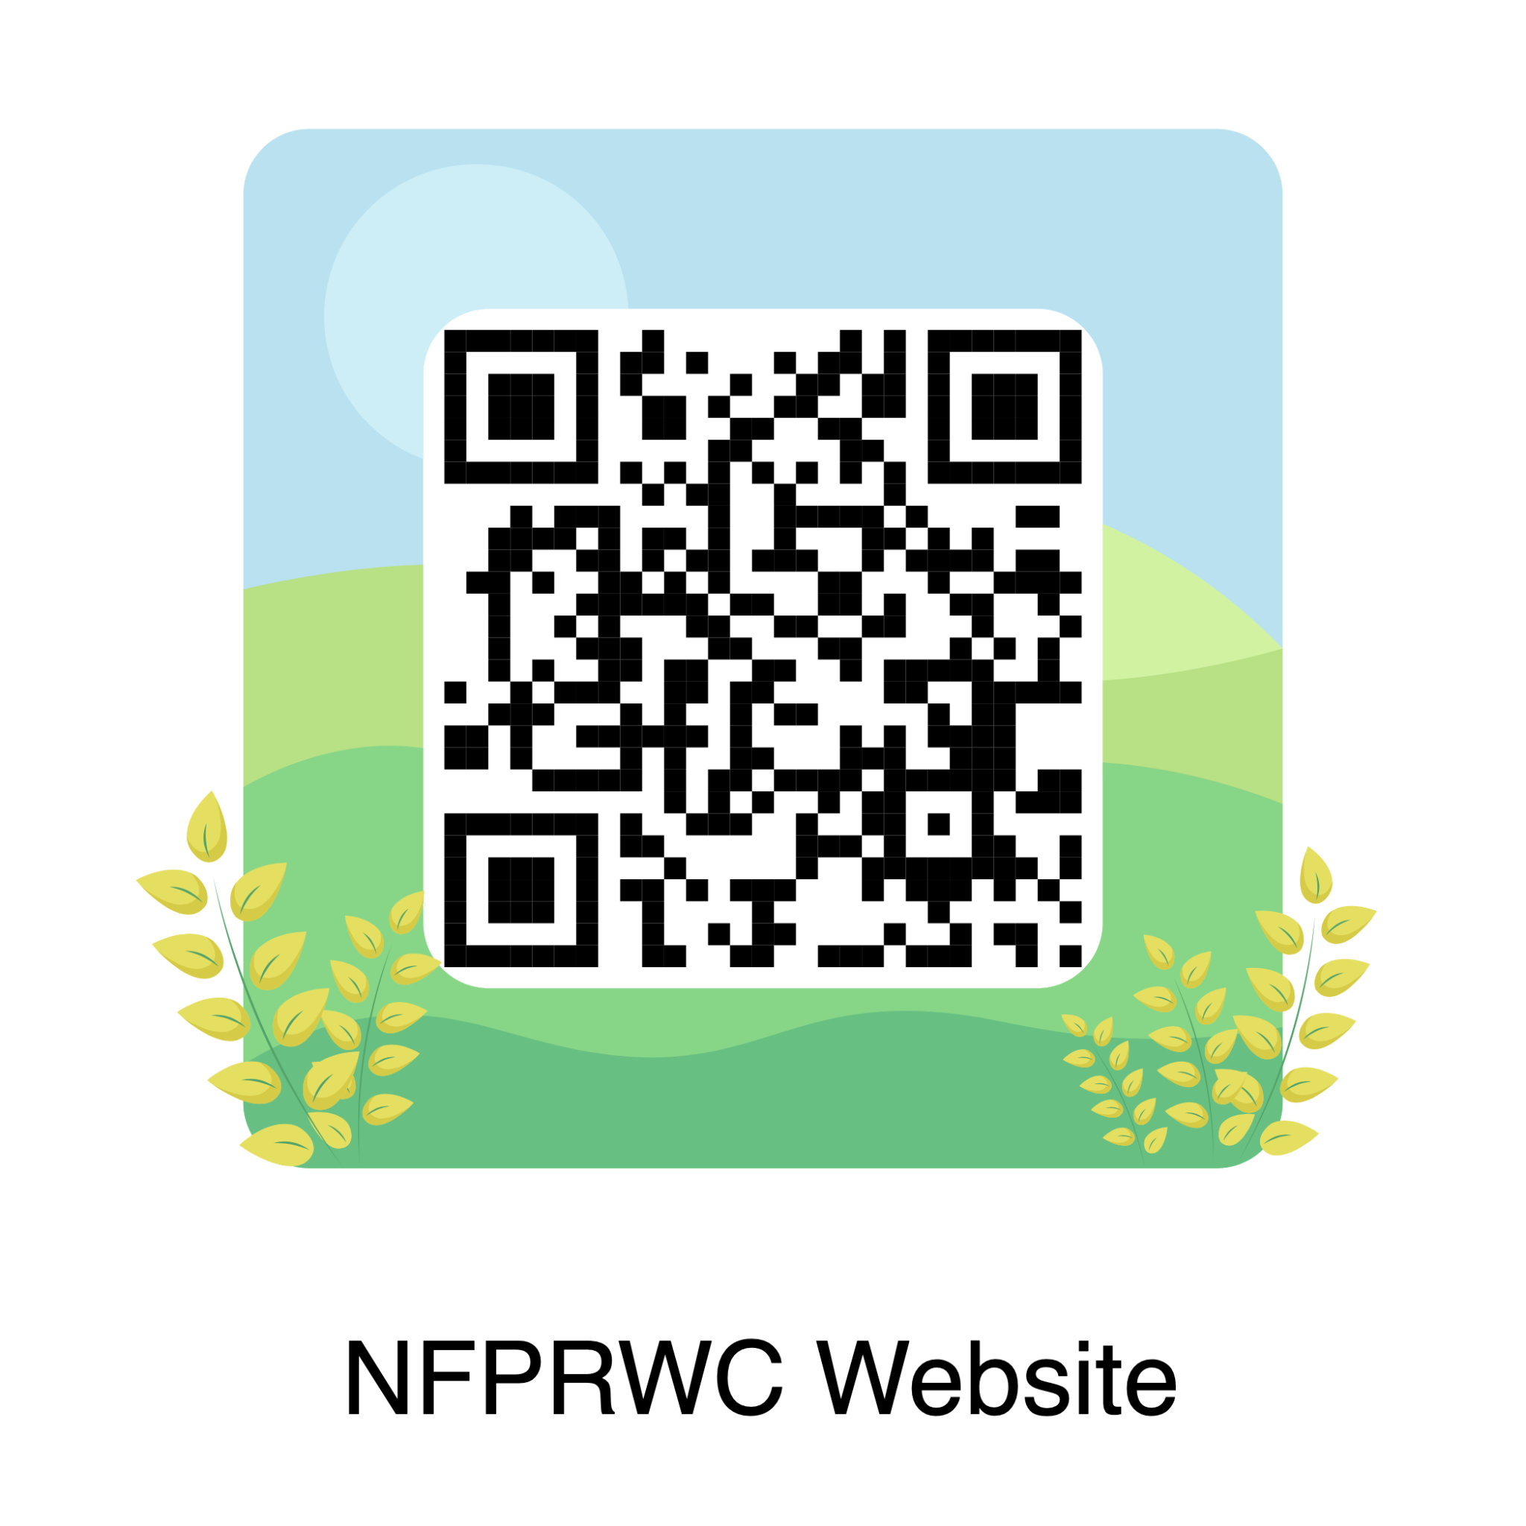Check the coalition website: www.valleyswcd.org

**Watershed Inventory Map:** <https://arcg.is/1zjTCr>

**Contact:**  Valley Soil & Water Conservation District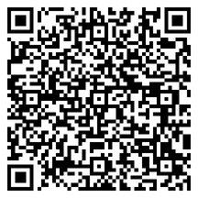

NFPayette@outlook.org

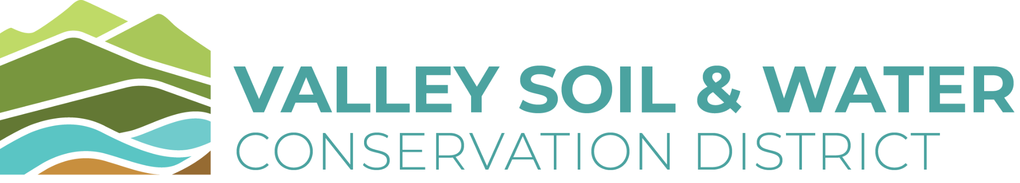[Durena.Farr@id.nacdnet.net](mailto:Durena.Farr@id.nacdnet.net)

**Leave us Feedback**