North Fork Payette River Coalition

Stream Condition Workgroup

**Date:** July 17, 2024; 10:00 am to 1:00 pm

**Location:** Idaho Fish and Game Office, 555 Deinhard Lane, McCall, ID 83638

**Attendance:**

Pam Pace: [pdixpace@gmail.com](mailto:pdixpace@gmail.com)

Nathan Stewart: [nstewart@mccall.id.us](mailto:nstewart@mccall.id.us)

Neil Shippy: [neil.waterdistrict65@gmail.com](mailto:neil.waterdistrict65@gmail.com)

Art Troutner: [atroutner@hotmail.com](mailto:atroutner@hotmail.com)

John Kwader: (no email)

Barb Nokes: [1considertheegg@gmail.com](mailto:1considertheegg@gmail.com)

Rob Mallery: [Robert.mallery@usda.gov](mailto:Robert.mallery@usda.gov)

Jen Ford: [Jennifer.ford@usda.gov](mailto:Jennifer.ford@usda.gov)

Tim Murphy: [tmarkmurphy1@gmail.com](mailto:tmarkmurphy1@gmail.com)

Wes Keller: [wesleyk@nezperce.org](mailto:wesleyk@nezperce.org)

Jordan Messner: [Jordan.messner@idfg.idaho.gov](mailto:Jordan.messner@idfg.idaho.gov)

Gary Brown: [bentwillowrods@gmail.com](mailto:bentwillowrods@gmail.com)

**Final Agenda:**

1. Quick review of the issues we’re addressing, format for this meeting, and end-of-meeting deliverables (Messner – 10 mins)
2. Introductions from participants (All – 1 hour / 5-10 mins each)
   1. What is your interest in this topic?
   2. What is your goal/objective for the workgroup?
   3. Do you have ideas for solutions that are ideal to your interests?
   4. Are there things you’re willing to lose/give up?
   5. What are non-starters for you (ideas you will NOT entertain)?
3. Discussion on topic 2 (All – 30 mins)
   1. What types of projects can we all agree on pursuing?
4. Identifying deliverables (All – 1 hour)
   1. Project prioritization
   2. Where do we start?
   3. Property and project identification
5. What’s next? (Messner – 20 mins)
   1. Action items

**10:00 AM** **Jordan opened** the meeting with an introduction of our subgroups purpose and the deliverables the group was tasked with. Our focus is on stream condition both from a user stand point (NF1) and from a stream quality stand point (NF3). Jordan put together the following slide to help highlight his points.

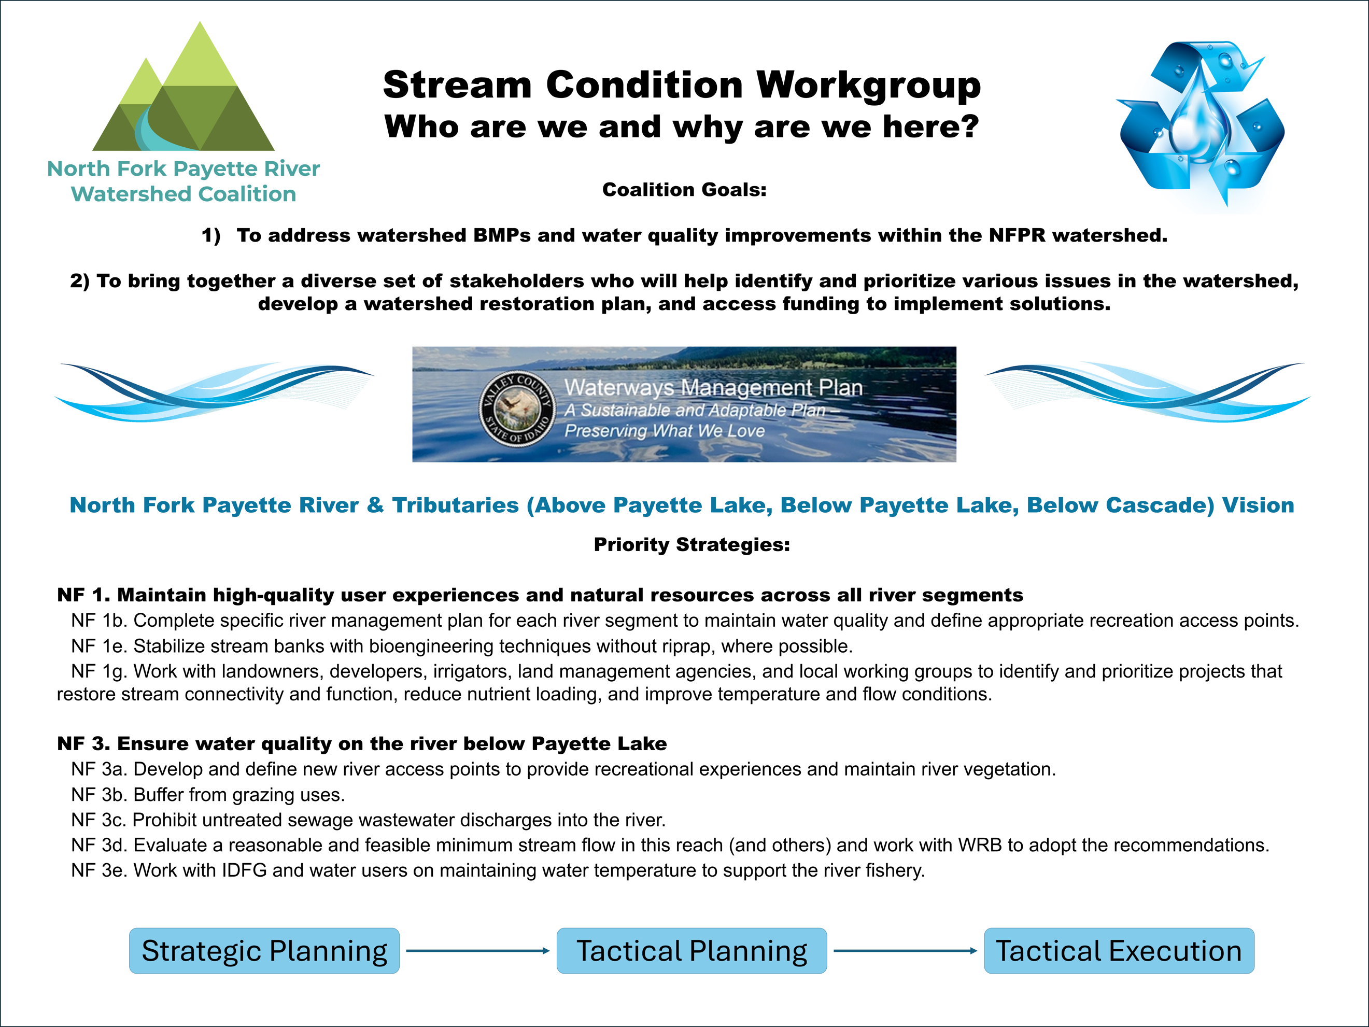

**10:10 am Introductions from Participants**

Pam Pace, Big Payette Lake Water Quality Council, Civil Engineer education, also worked for Idaho Department of Water Resources and Idaho Power

Nathan Stewart, McCall Public Works Director, Engineer and Aquaculture education, also has land developed and planning experience

Neil Shippy, State Watermaster for District 65, most of the Payette River drainage, extensive expertise in water systems and deliver

Art Troutner, Valley Soil Water Conservation District Chair (40yrs) and Lake Irrigation District Board Member (20yrs), Farmer and Carpenter

Rob Mallary, Payette National Forest Natural Resource Staff Officer

Tim Murphy, Commissioner for Idaho Department of Fish and Game, Range Land Management education, worked for Forest service and Bureau of Land Management

Barbara Nokes, Ranch Owner and Operator, Nurse by education and practice

Gary Brown, Trout Unlimited, Forester by education, worked for Forest Service

Wes Keller, Watershed Manager for Nez Perce Tribe, Watershed and Fisheries education

John Kwader, Ranch owner and Operator, Forestry education, long time Forester for Boise Cascade Company

Jen Ford, Payette National Forest Watershed Manager

As part of our introduction’s participants were tasked with reporting out on what our interests in this topic are, what are our goals and objectives for the work group, report any solutions or ideas we may have and list what we are willing to give up or lose and finally what are our non-starters. Jordan recorded those results as listed below. Notes reflect exactly what was written on each sheet, thus no lumping or editing.

**Interest in Topic**

* Improving fisheries and having cold/clean water
* Maintain and improve water quality and quantity while maintaining economic viability for agriculture practices
* Water quality in Cascade Reservoir
* Keep fish in the stream
* Improve irrigation efficiency
* Reclaim natural stream channels
* Keep fish in the stream
* Protect water quality in Payette Lake
* Sustainable water Quality
* Provide a vision for future environmental sustainability, rels to meet that vision(not sure what this is supposed to say)
* Watershed restoration
* Protect, maintain and improve NFPR corridor
* Ensuring irrigators get their water

**Goals and Objectives for the Work Group**

* Unified direction to project identification and implementation
* Fish in streams
* Survey of riparian zones in watershed, more fencing needed
* Fish in Streams
* Restore native species and watershed health
* Restore stream connectivity specifically Gold Fork
* Address Phosphorus in Payette lake
* Incorporate economic and social sustainability in water quality improvements
* Investment into our community and land planning policy
* Create, protect and maintain biological corridors
* Ensure process and recommendations are data driven
* Work effectively across boundaries
* Help secure funding to get work done
* More rounder involvement – working together on solutions
* Incorporate TU funding

**Ideas and Solutions for the Work Group**

* Hypolimnetic withdrawal
* Riparian fencing
* Transfers
* Fish screening
* Increased storage capacity
* Septic policies
* South lake sewer district
* Pipe canals and ditches
* Increase education and preplanning for stewardship
* Screening and fish ladders
* Riparian fencing
* Beaver engineering
* Implement University of Idaho recommendations
* Increase water quality monitoring
* Implement recommendations in 1999 WRB report (need to type out WRB)
* Look to IPC for recommendations on reducing stream temperatures (need to type out IPC)
* Cloudseeding (increased volume by 12%)
* Work with land trust
* Create land planning policy
* Road work to reduce sedimentation and protect riparian zones
* Beaver engineering
* Bank stabilization
* Buffer zone policy and education
* Purchased excess storage in Cascade Reservoir

**Willing to Give Up**

* Short term losses for long term goals

**Non – Starters**

* Policy action that would impede agriculture users or economic viability of operations
* Too expensive
* Need to keep irrigating
* Accept new projects without research to determine effects (do no harm)
* Going down a path of unsuccessful attempts
* Unwilling to work together and compromise

**11:50 Lunch Break**

**12:15** During lunch Jordan summarized our list of overlapping Interests and Goals along with summarizing Ideas and Solutions for improvements. Jordan lead us through. Short discussion of these items and a few were added to the list Jordan had created.

**Overlapping Interests and Goals**

* Maintain and improve water quality
* Improve fisheries resources
* Protect stream and riparian corridors
* Work together in unified direction
* Inform planning and policy for future development
* Preserving and improving water quantity

We then used a voting process (red sticky 2 votes, blue sticky 1 vote, each person got 1 red and 2 blue sticky’s) to identify the Ideas and Solutions that are favored by the group.

**Ideas and Solutions for Improvements**

Modeling Needed (including literature and input from collaborators)

* Water transfer
* Sprinkler conversions
* Increased reservoir storage
* Piping canals/ditches
* Cloudseeding

Brown colored items, no title listed for this one

* Beaver dam analogs
* Riparian fencing
* Bank stabilization and shading
* Increased data collection – fill in gaps
* Fish screening and passage

Policy and Education Development

* Septic policies
* Recreation planning
* Development planning
* Education campaigning

Voting results from the above list:

8 votes: Development Planning

7 votes: Water Transfers

7 votes: Bank Stabilization

7 votes: Fish Screening and Passage

6 votes: Increased Data Collection – fill in gaps

3 votes: Education campaigning

2 votes: Increased Reservoir Storage

2 votes: Cloudseeding

1 vote: Septic Policies

Sprinkler Conversions, Piping Canals and Ditches, Beaver Dam Analogs, and Recreation Planning did not receive any votes

**1:00 pm. Meeting Concluded**

**Work Assignments resulting from today’s meetings:**

1. No work assignments were identified

=====================================================================

**Next Meeting:** Jordan will send out a doodle poll to schedule the next meeting, tentatively planning for the end of August

**Possible Topics/Agenda Items:**

* Review discussion from last meeting
* Discuss the winners from our voting from last meeting and how we will move these ideas forward